Pre-K4 Class Supply List/ Articulos Escolares de Pre-K4
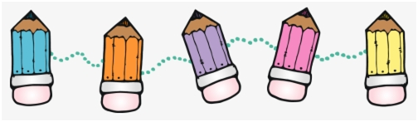
Each day your child will need to bring:
Cada día su hijo tendrá que traer:

-a backpack large enough to hold a folder (una mochila)
-a folder with two pockets (una carpeta)
-a lunchbox (una lonchera)
-a lunch with a healthy snack and drink - children can purchase lunch too (un almuerzo con un bocadillo y una bebida-las niñas también pueden comprar el almuerzo).

Your child will also need these school supplies to be kept in the classroom:
Su hijo también necesitará estos útiles escolares para mantenerse en el aula:

*1 plastic pencil box similar to the link provided (una caja de lápices de plastico)
https://www.dollartree.com/translucent-plastic-pencil-boxes-with-colored-lids-85x225x2375-in/307582
*2 LARGE glue sticks (2 barras de pegamento grandes)
*1 Elmers liquid school glue (pegamento líquido Elmers)
*a pack of fat Crayola washable markers (marcadores Crayola)
*a pack of 24 Crayola crayons (24 crayones de Crayola)
*1 pack of baby wipes for cleaning hands during art (1 paquete de toallitas húmedas)
*If your child receives speech services in school they will need 1 marble notebook OR return their speech book from the year prior (Si su hijo recibe servicios del “speech” en la escuela, necesitará 1 cuaderno de mármol O devolverá su libro del año anterior)

Your child will need these personal supplies to be kept in the classroom:
Su hijo necesitará estos suministros personales para mantenerse en el aula:

-a full change of clothing LABELED with your child’s name (ropa extra etiquitada con el nombre de su hijo)
-a smock or oversized t-shirt for art class LABELED with your child’s name (bata para el arte)
-A crib size sheet, a blanket, and small pillow for rest time LABELED with your child’s name (sábana del tamaño de la cuna para la siesta con la manta y almohada)
If you have questions about the supply list or are having difficulty obtaining the supplies, please email the Pre-K staff at kreilly@moonachieschool.org or acuccarese@moonachieschool.org prior to the school year beginning. (Si tienes preguntas o si necesita ayuda para obtener alguno de los suministros, comuníquese con kreilly@moonachieschool.org o acuccarese@moonachieschool.org) Thank you! We look forward to a fun year!

